**CASE STUDY - GIT WORKFLOW**

**Problem Statement:**

You work as a Devops Architect in Zendriix Softwares. The company has been struggling to

manage their product releases. The releases should happen on 25th of every month. Suggest a

Git Workflow Architecture for this requirement.

Simulate this workflow, by creating a pseudo code files and branches, and upload the same to

your GitHub Account.

As a part of solution, share the link to your GitHub repository.

hotfix hotfix branch urgent.txt

**Master branch master.txt f1.txt f2.txt**

Develop/test branch f1.txt f2.txt

F2 branch f2.txt

**F1 branch f1.txt**

On master branch

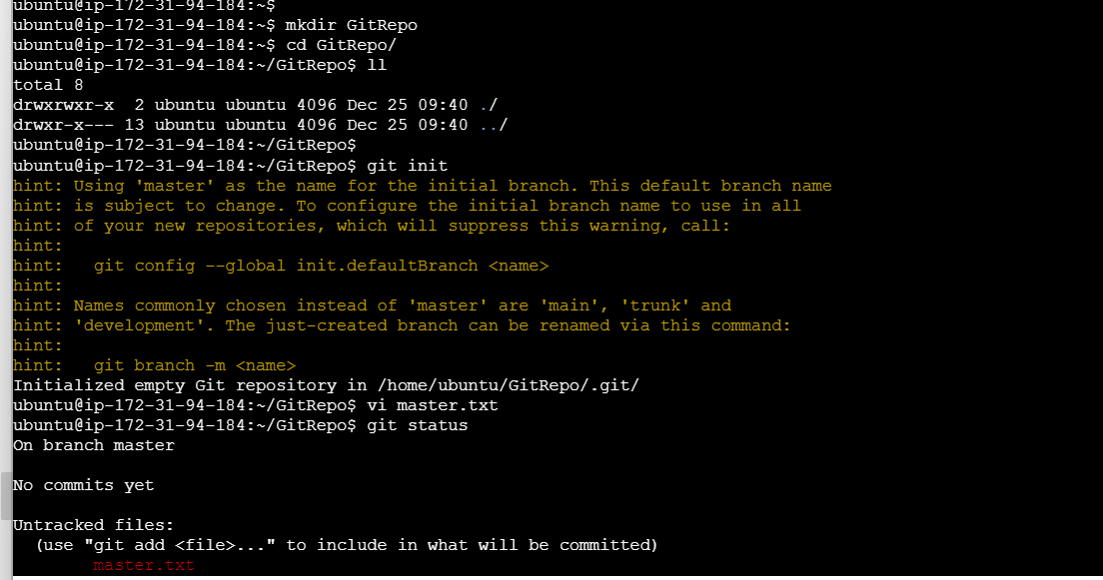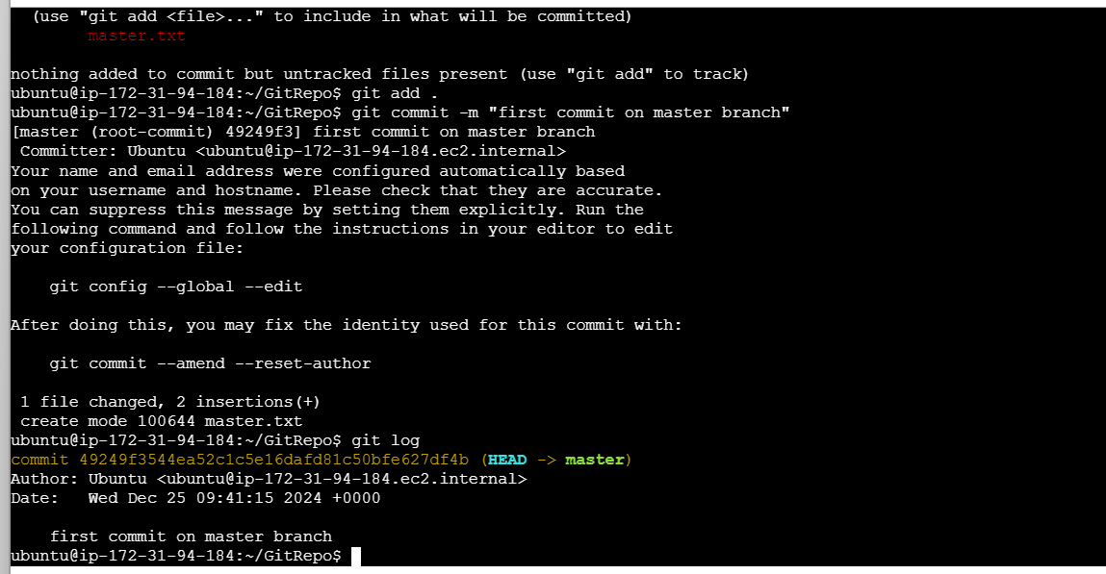

Create f1 branch

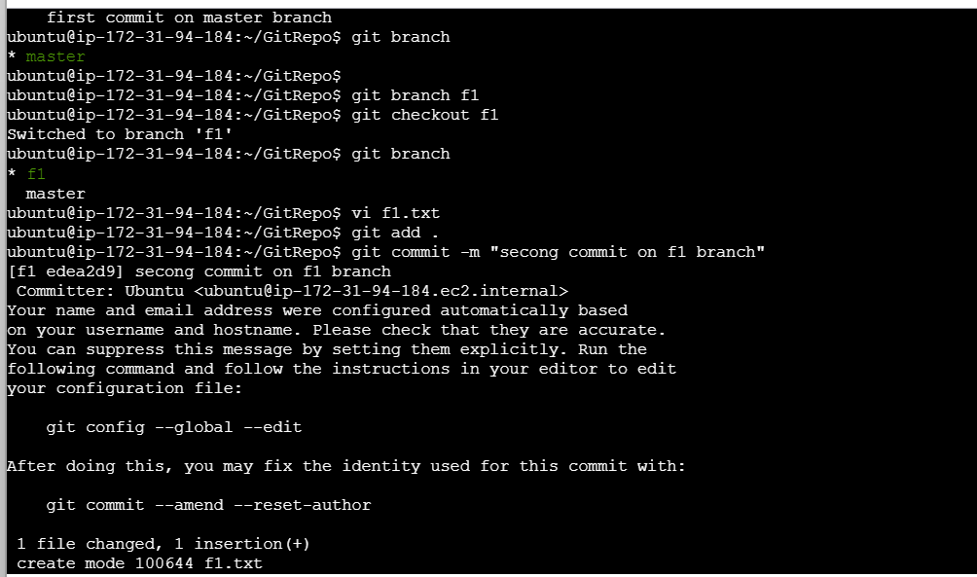

Create f2 branch

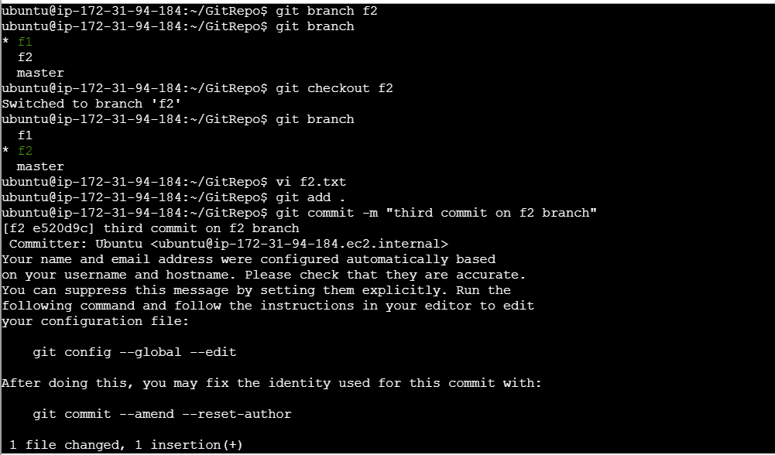

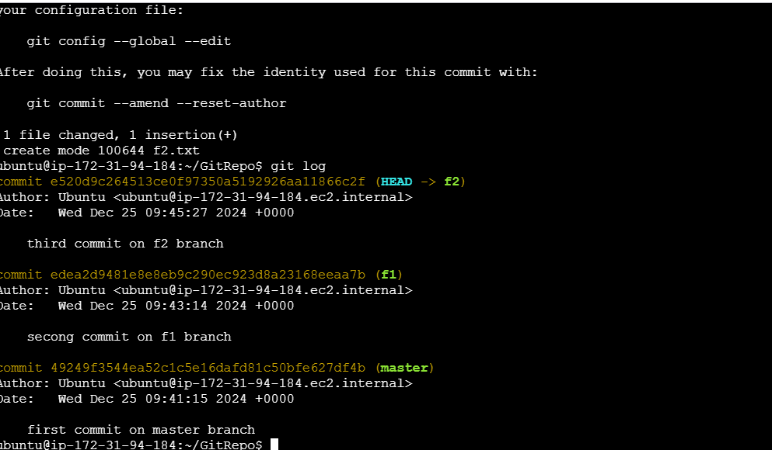

Create develop branch and merge f1 and f2

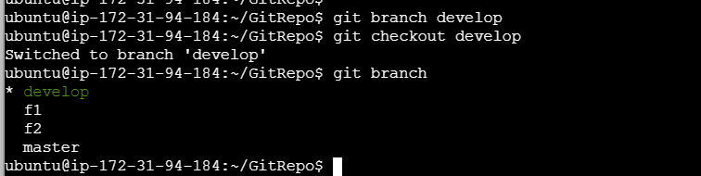

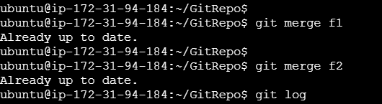

All changes are updated on master branch

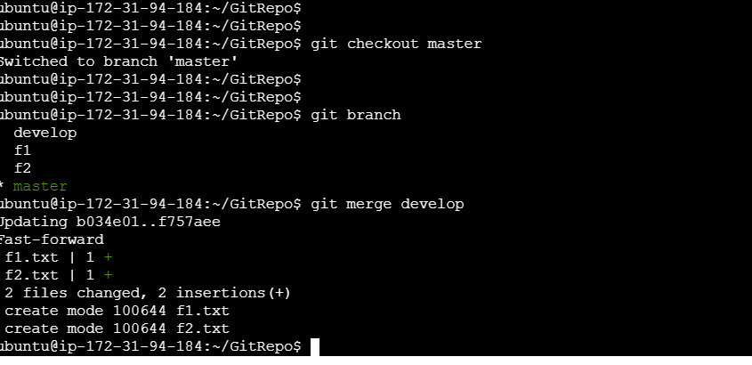

Create hotfix branch and commit urgent.txt after that merge it to the master branch

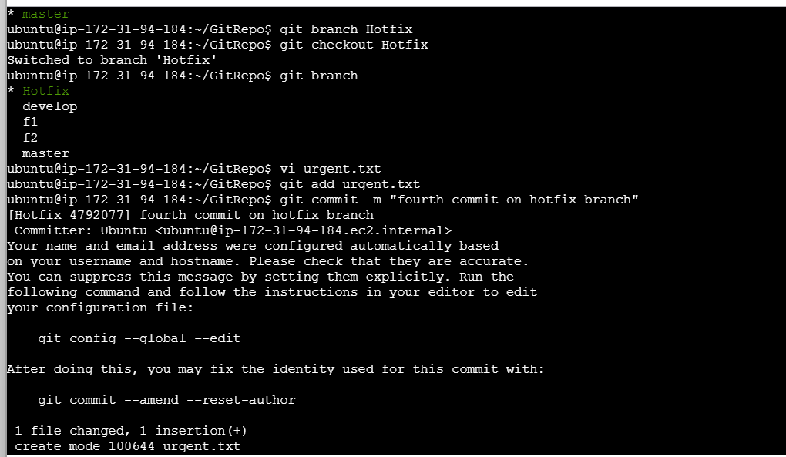

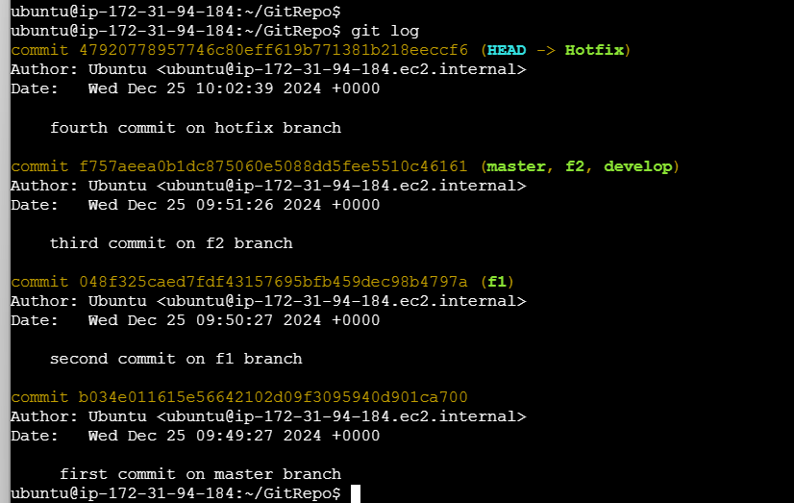

Merge on master

